**Data Flow Diagrams:**

**Project Design Phase-II Data Flow Diagram &User Stories**

|  |  |
| --- | --- |
| Date | 12 November 2022 |
| Team ID | PNT2022TMID07793 |
| Project Name | Project – **REAL TIME RIVER WATER QUALITY MONITORING AND CONTROL SYSTEM** |
| Maximum Marks | 4 Marks |

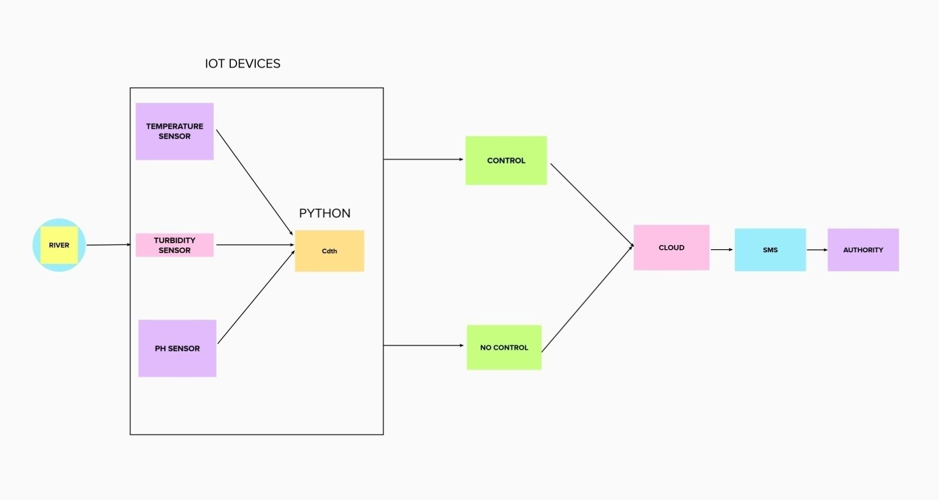

**User Stories**

Use the below template to list all the user stories for the product.

|  |  |  |  |  |  |  |
| --- | --- | --- | --- | --- | --- | --- |
| **User Type** | **Functional**  **Requirement (Epic)** | **User Story Number** | **User Story / Task** | **Acceptance criteria** | **Priority** | **Release** |
| Circuit designer | Designing the circuit | USN-1 | As a user, I can design the circuit by using open source softwares. | I can get the exact design for my project. |  |  |
|  |  | USN-2 | As a user, I can design the circuit by using free web app like Tinkercad. | I can make several attempts to get the right  design. |  |  |
| Programmer | Create a program suitable for the circuit | USN-3 | As a user, I can create programs in the user friendly language. | I can create a simple program for the circuit |  |  |
|  |  | USN-4 | As a user, I can compile and execute the programs. | I can get the program with accurate outputs. |  |  |
| Engineer | Connects the output to the cloud | USN-5 | As a user, I can connect the output values to the cloud services by using NODE RED. | I can make the datas to receive in cloud. |  |  |
|  | Store the output values | USN-6 | As a user,I can make the data’s store in IBM cloudant database. | I can retrieve the data anywhere,anytime. |  |  |
|  | Connects the cloud data with the authorities communication  device. | USN-7 | As a user,I can produce connection to the authorities mobile phones so that they can receive the alerts. | I can make the authorities informed about the water’s quality. |  |  |
|  | Alerts has to be sent to the authorities | USN-8 | As a user,I can make use of platforms such as Fast SMS to send the timely updates to the authorities. | I can make the authorities to get accurate values and alerts |  |  |
| Authorities | Checks the water quality alerts | USN-9 | As a user ,I check the quality values of the water that is sent to me . | I can make sure that the people in my zone gets  quality water. |  |  |
|  |  |  |  |  |  |  |
|  |  |  |  |  |  |  |
|  |  |  |  |  |  |  |

**Analysis, Intepretation and Modelling**

# Analysis:

In this project ”Real time river water quality monitoring and control system” ,the river water temperature ,ph and turbidity values are monitored and the water’s quality can analysed.

* To ensure the supply of quality water.
* To improve the quality of life.
* To reduce the spread of water borne diseases.

# Intepretation:

* River water quality can be monitored by the web application.
* Can be able to know if there are any dust particles present in the water.
* The PH level of the water can be monitored.
* Water temperature can be monitored.
* Alerting the authorities if the water quality is not good so that they can go and announce the localities not to drink that water.

# Modelling:

